

Jordanian Startups Map

By

Nada Alaghbar

Supervisor:

Joseph Botrous

A REPORT

Submitted in partial fulfillment of the requirements  
for the National ICT upskilling program.

Front-end Web Development

Al-HUSSEIN TECHNICAL UNIVERSITY - HTU

National ICT Upskilling Program

2023

**ABSTRACT**

Jordanian Startups Map is an online platform where users can figure out startups in different fields in Jordan. Users are able to find a specific startup within a particular category for a sub-sector that they are interested in. To make it friendlier for users, it features a responsive, beautiful, easy-to-use design layout.

**Table of Content**

**Chapter 1: Introduction**

1.1 Purpose

1.2 Project Overview

1.3 Background

**Chapter 2: System Requirements & Functionality**

2.1 System requirements

2.2 End-user functions

2.3 Administrator functions

**CHAPTER 3: Design and Implementation**

3.1 Design

3.2 Database and Implementation

3.3 Diagram

**Chapter 4: Testing**

**Chapter 5: Conclusion**

**Chapter 6: Reference**

**Chapter 1: Introduction**

**Project link:**

<https://stratups-map-47b6a.web.app/>

**1.1 Purpose**

The project's primary goal is to build a website that enables visitors to look for and contact startups based on Startup Name and industry. The user may see what he is looking for by viewing the startup's logos in a grid format. Comparing the Administrator to the end user, the Administrator will have more features.

The need to establish a user-friendly website that allows users to communicate with companies they are interested in was the driving force behind this project.

**1.2 Project Overview**

The start-UP platform allows users to find the available startups in the Jordan market and be able to browse through them and learn about them, then they can be able to join, contribute or even invest in developing these Startups.

**1.3 Background**

A startup map is an online dynamic platform for documenting startups in Jordan, where users can learn more about the startups and contact them.

Through a web browser, the startup owners can submit a form to request that their startup be shown on the website landing page. The users and the startup owners doesn’t need any kind of authentication to use the website landing page because it is well-implemented to be easy to use and shows all the information that the user seeks.

Startup's owners can easily fill out a form that submits their request, then the admin checks the information of the request and accepts the request to be shown on the home page.

The admins have full control over the website with an external dashboard in their interface.

**Chapter 2: System Requirements & Analysis**

**2.1 System requirements**

As the goal of the application is ease of use and to provide an interactive interface, extensive research has been done to gain insight into the needs and behaviors of various users.

**2.2 End-user functions**

This project has the following functionalities:

* Landing page.
* Logos grid list
* Requests form
* Contact us page
* About us page
* Frequently asked questions page

**2. 3 Administrator functions**

* Login
* Logout
* Add startups or sectors
* View startups details
* Update startups
* Delete startups
* Accept or Reject requests

**Chapter 3: Design and Implementation**

**3.1 Design**

In this project, several technical tools are used:

* HTML to build the structure of a web page.
* CSS for design.
* Media queries to make the website responsive.
* JavaScript to manipulate data from the web within a web browser
* Firebase (Firebase authentication, Storage, Firestore)
* Angular Framework (Forms and material)

In the system, we can observe that the user interacts with the application through a graphical user interface. The inputs to the system are the requests provided by the user. Also, the output is in a grid view which presents the users with a list of active startups.

**3.2 Database and Implementation**

The database was designed and implemented using google Firebase which allows for building a real-time database and storage.

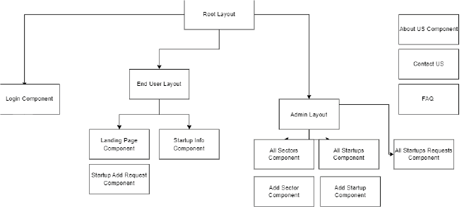**3.3 Diagram**

Figure 1. Project diagram - Modules and components

As shown in figure 1, there are two main modules in the project, which are admin and user, and each one of them has many components such as a view dashboard and request form for the user, and a full control dashboard for the admin. The home page, contact, about, and FAQ are shared pages. In addition, there is a login page that is mandatory for the admin to login with his email and password in order to be able to access the dashboard.

**Chapter 4: Testing**

Software testing is a periodical process of running with the intent of finding errors in software. Software testing assures the quality of software and represents a final review of other phases of software like specification, design, code generation, etc.

* Verify user request submission.
* Verify user can view all startup’s logos and data.
* Verify admin can view all sectors and startups.
* Verify the startup profile on the admin page can be updated and deleted.
* Verify requests on the admin page can be approved and rejected
* Verify layout is easy to use.
* Verify responsiveness.

**Chapter 5: Conclusion**

Start-up is designed to provide a web-based application that would make searching, viewing, and selecting startups easier. The use of Ajax & Observable components would make the application interactive and prevents annoying post backs User can view contact information about the startup he is looking for.

Using Angular framework make a quick one-page application, and firebase database gives a real-time data exchange experience, all to make the user comfortable when he uses the platform.

**Chapter 6: References**

1. Team, N. Z. (n.d.). NG-ZORRO - Angular UI component library. NG-ZORRO - Ant Design of Angular. Retrieved February 1, 2023, from <https://ng.ant.design/>
2. Team, A. C. (n.d.). Angular Material. Angular Material. Retrieved February 1, 2023, from https://material.angular.io/
3. Now UI Kit Angular by Creative Tim. (n.d.). Creative Tim. Retrieved February 1, 2023, from https://timcreative.github.io/now-ui-kit-angular/index